ANNEXURE 1

Autonomous drones can greatly reduce the risk of piloting errors in agriculture. The flowchart below depicts the autonomous operation of drones by incorporating AI into the drone. First, we must create the algorithm that will allow the drone to operate autonomously, and then we must connect the drones in the system. The source waypoints can be taken as input from Google Maps; then the code is implemented into the drone; then the border points of the crop fields where it needs to fly are mapped; the drone status from the ground station is obtained to determine whether it is ready to fly or not; and the drone returns to home after the mission or when the battery charge runs out.

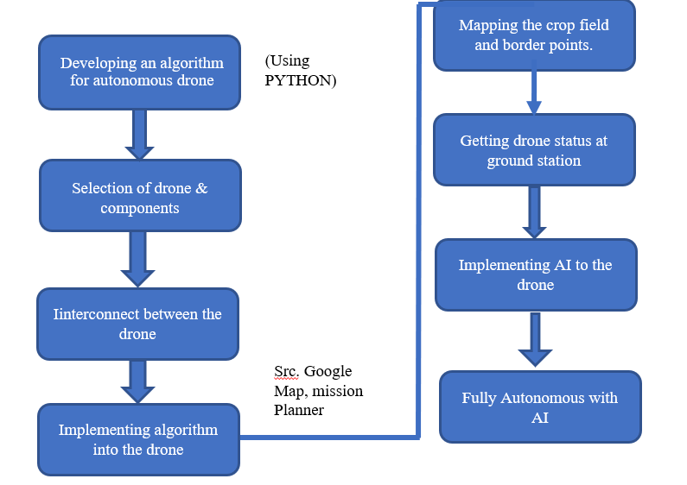

ANNEXURE 2

1. A method for sorting out the piloting error.
2. A method as we claimed in 1, To constrain the drone movements within the area.
3. A method as we claimed in 1, To adjust the altitude of drone at uneven area like Slanting area.
4. A method as we claimed in 1, To make the drone to return home Feature for autonomous return to the start position when the battery voltages reduce

ANNEXURE 3

Drones commonly referred, as UAVs are mostly associated with military, industry and other specialised operations but with recent developments in the area of sensors and Information Technology in the last two decades the scope of drones has been widened to other areas like Agriculture. The drones manufactured these days are becoming smarter by integrating open-source technology, smart sensors, better integration, and more flight time, tracking down criminals, detecting forest and other disaster areas. In this abstract, we demonstrate the design and development of an aircraft type autonomous drone suitable for pesticides spraying in agriculture. Nowadays, autonomous drones fly by with the support of external software like Agri-assistant, Q-controller etc. instead of using external software, we are going to make real time mapping, constrained path for the movements. It is an AI powered drone, which flies in a fixed path and has an obstacle sensing system. The drone can fly under different altitudes varying from 10 to 50 metres. The agricultural drone has a return to home feature for autonomous return to the starting position, when its battery voltage reduces down to a certain level or any communication failure is detected.

**Keywords: Ai Powered Drone, Open Source, Constrained Path, Agriculture Drone**